CSE 4571 – PRACTICAL ROBOTICS PROJECTS WITH ARDUINO
EXPERIMENT 5
SENSOR-BASED AUTOMATIC ACTUATOR CONTROL SYSTEM
Duration | Level | Mode | CO Mapping
2 Hours | B.Tech CSE Final Year | Hardware / Wokwi | CO2, CO3, CO4
1. Aim of the experiment
To integrate a PIR motion sensor, servo and buzzer to create an automatic robotic response.
2. Objectives
- Read a digital motion event.
- Apply conditional control.
- Move an actuator automatically.
- Generate an event alert.
3. Components / TinkerCAD or Wokwi Parts
Component | Qty. | Purpose
Arduino UNO | 1 | Microcontroller
PIR sensor | 1 | Motion-event input
Micro Servo | 1 | Automatic actuator
Buzzer | 1 | Event alert
4. Theory
A robot combines sensing, decision-making and actuation. A PIR provides a digital motion event; the Arduino converts that event into an actuator command. In this experiment, motion commands the servo to 90° and activates a 1500 Hz buzzer tone. With no motion, the servo returns to 0° and the buzzer is silenced.
5. Pre-Lab Questions
- What is a digital sensor?

- Why is conditional logic central to robotics?

6. Connection Table
Signal | Pin | Function
PIR OUT | D2 | Digital motion input
Servo signal | D9 | Servo command
Buzzer | D6 | Alert output
VCC | 5V | Supply
GND | GND | Common ground

7. Circuit Diagram for Implementation
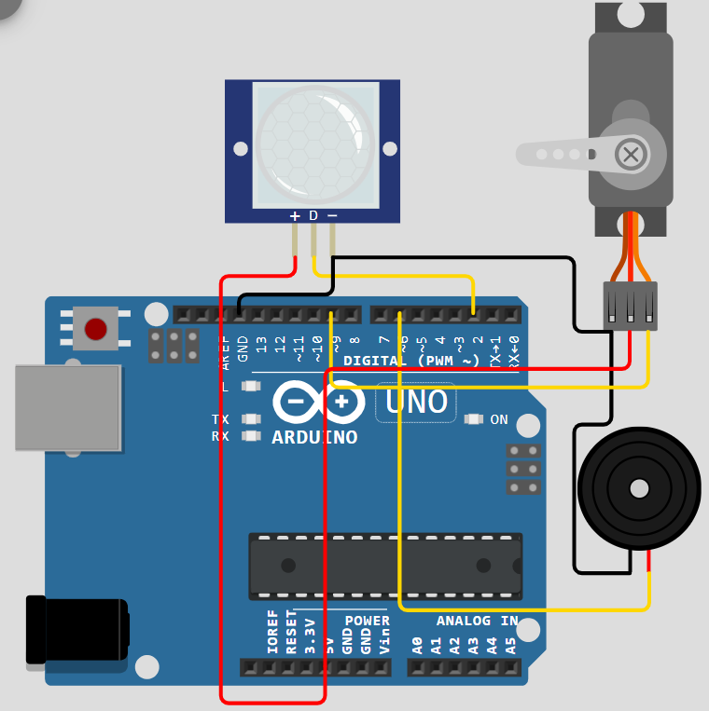
Figure 1. Verified PIR–servo–buzzer automatic response circuit.
8. Circuit Diagram Implemented Using Hardware’s

9. Procedure
- Build the circuit.
- Run the program.
- Trigger motion in Wokwi.
- Observe servo and buzzer response.
- Repeat and record motion/no-motion behavior.

10. Arduino Program

11. Observation Table
Sl. No. | Motion State | Servo Angle | Buzzer State
1
2
3
4
5
12. Expected Output / Analysis
Motion: Serial Monitor shows MOTION, servo moves to 90°, and the buzzer sounds at 1500 Hz.
No motion: SAFE is displayed, the servo returns to 0°, and the buzzer is silenced.
13. Result
The PIR sensor, micro servo and buzzer were successfully integrated to demonstrate automatic sensing, conditional decision-making and actuator/alert response in Wokwi.

14. Post-Lab Questions
- Keep the gate open for 3 seconds after motion.

- Add a second sensor and define an AND condition.

- What is event-driven control?

15. Precautions
- Verify pin assignments before running the simulation.
- Use common ground for connected devices.
- Record both input condition and observed output.
- For physical implementation, consider current, voltage, mechanical loading and sensor tolerances.
16. Suggested Extension
Modify the program to add one meaningful feature, document the change, and preserve the original behavior as a baseline.

17. Student Record

Student Name | Registration No. | Date | Faculty Signature

